Use Case Realisation Report - Manage ProjectRegister volunteer account
FOR
Volunteer Management System
(VMS)

CLIENT
PROJECT | Volunteer Management System (VMS)
TITLE | Use Case Realisation Report - Manage ProjectAccount
VERSION | 0.1a
DATE | 13-Aug-2011
 | ORIGINATOR
 | Name / Signature | Team 8S
 | APPROVAL
 | Name / Signature | Phung Kim Cuong, Dio
Institute of Systems Science |  | Document Reference
25 Heng Mui Keng Terrence  Singapore 119615 |  | VMS/PM-1.3.1/1

 | Acceptance
 | Customer Signature |  | Customer Signature
 | Name & Designation |  | Name & Designation
 | Date & Company Stamp |  | Date & Company Stamp

Revision History

Date | Version | Description | Author
12-Jun-2011 | 0.1a | Creation | Team 8S
 |  | Refer to amendment history

Table of Contents

1. Brief Description 3
2. Flow of Events 3
2.1 Standard Flow 3
2.2 Exceptions 3
3. Interaction Diagrams 3
3.1 Domain Collaboration Diagram: Register Volunteer Account 3
4. Participating Objects 4
5. Derived Requirements 4
ANNEX D Amendment History 4

Use-Case Realization Report
Register Volunteer Account

Brief Description
The use case describes the new volunteer account registration of VMS system.

Flow of Events
The standard flow of events for this use case and any exceptions are described in the following subsections. See section 3.1 for an overview of the participating Actors and Domain Objects.

Standard Flow
This use case provides the user interface related functionality that will be provided to the User, as follows:
To commence using the system functions, the general public can sign for a new account as follows:
- The User clicks ‘Register’ URL on system Header and the system are redirected to SecurityScreen.
- A new user input form will be displayed to enable user enter following information:
- Email address
- Password
- Full Name
- Date of Birth
- Gender
- Nationality
- Interests
- Language Proficiency
- Profession
- Contact
- Address
- When user click ‘Submit’ button, the securityScreen will use the validateFormat() to check the input info format
- If the user info isn’t correct, the displayMsg() method of SecurityScreen is triggered to display the error message on the screen
- If the use info is correct, the createNewUser() method of SecurityController will be triggered
- The system use the getAllUsers() of User entity to get a list of registered users
- If the user mail has already existed, the displayMsg() method of SecurityScreen is triggered to display the error message on the screen
- If the user mail has not registered, the create() method of User object will be triggered to create a new object and save to database
- The sendEmail method of external IF ExchangeServerIF is used to send an email to user
- The displayMsg() method of SecurityScreen is triggered to display the success message on the screen
- The system is redirected to HomeScreen upon the successful new account registration

Exceptions
The following exceptions have been identified:
- Invalid Password. If the new password doesn’t conform to the security format, system will prompt the format tips to assist users
- Invalid email address. If the email address is registered, system will prompt error message

Interaction Diagrams

Domain Collaboration Diagram: Register Volunteer Account

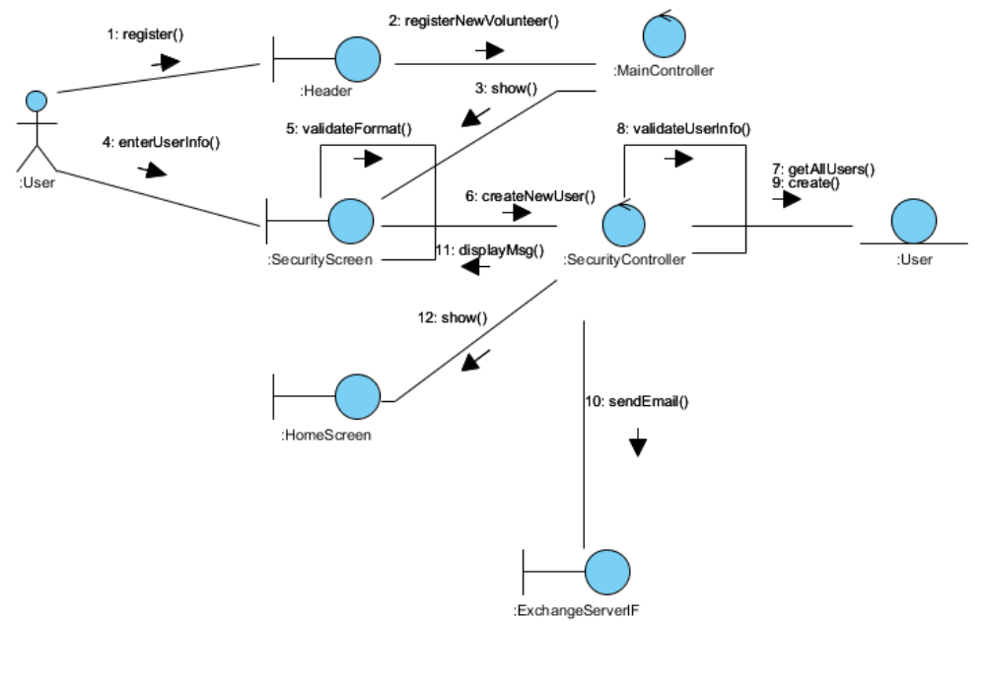

Participating Objects
:
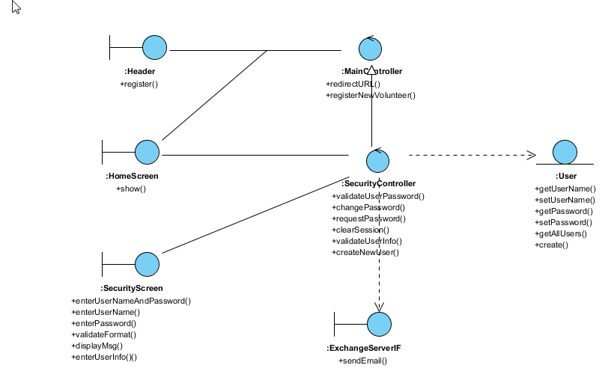

Derived Requirements

ANNEX D Amendment History

This is a record of all amendments made to the Document.
Version | Chapter / Section | Page No | Notes of Amendments or Changes

